The Easter Sepulchre at St Mary’s Bampton
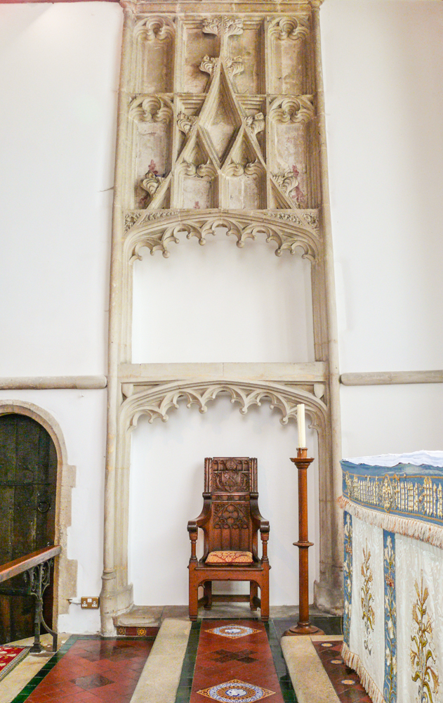
What is an Easter Sepulchre?
The Easter Sepulchre was an innovation in church architecture and practice in the 15th century. There are typically three parts to the structure: a more or less elaborate stone framework, statues and carvings, and a tabernacle. In this context a church tabernacle is a decorated wooden box which is used to hold the sacrament once it has been consecrated. The carvings typically represent the soldiers who slept outside the tomb, and/or the angels and the women who meet at the empty tomb. These features are normally found in Pre-Reformation churches in England and Wales.
The most significant use of the Easter Sepulchre is that the bread and wine consecrated at the last communion service on Maundy Thursday are stored in the Easter Sepulchre until they are removed for the service on Easter Sunday. This is a symbolic recreation of Christ’s body being placed in the tomb and his resurrection on Easter. The word sepulchre comes from the Latin verb “to bury” and on its own simply means a burial place.
What is special about the Sepulchre at St Mary’s?
The Sepulchre at St Mary’s is “double”, that is, it has two large bays topped by a large decorative panel featuring cusping, crockets and finials. Here are some examples of each:

Cusping:
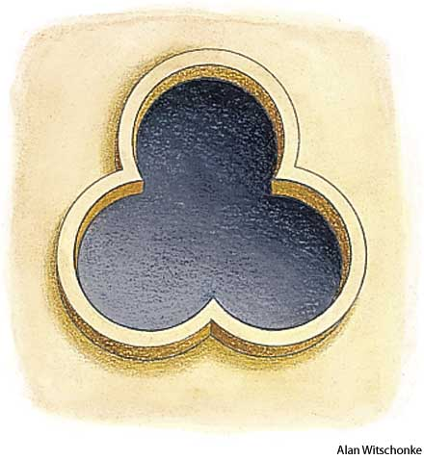
Crockets:
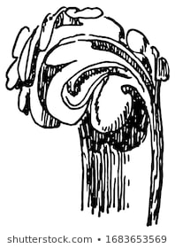
Finials:
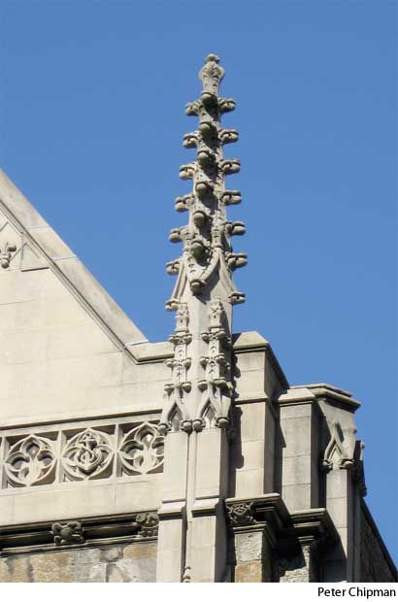
These decorative elements put it in the mainstream of late 15th century church decoration. Furthermore, it is highly unlikely that such a feature would have been commissioned and installed later than 1530 because of the raging religious passions of the English Reformation. Sadly, today the traditional wooden tabernacle is missing. In its day it would have stood (perhaps on legs or a plinth) in the lower large bay. At two metres from the ground, the upper bay is too difficult for the celebrant to access. We can only surmise that the tabernacle was removed by reformers or puritans as being too Roman Catholic for their tastes. There was a move to cleanse the churches of such features during the reign of Edward the VI (1547-1553). Perhaps that is when the statues in the six niches, if there were any, were removed. Later, features like Easter Tabernacles were a particular target of the Puritan parliaments of the 1640’s, which called for the removal and destruction of “monuments of superstition” in a series of ordinances. It is improbable good fortune that left the stone elements of St Mary’s Easter Tabernacle for us to enjoy today.
Dr Ernest Parkin

